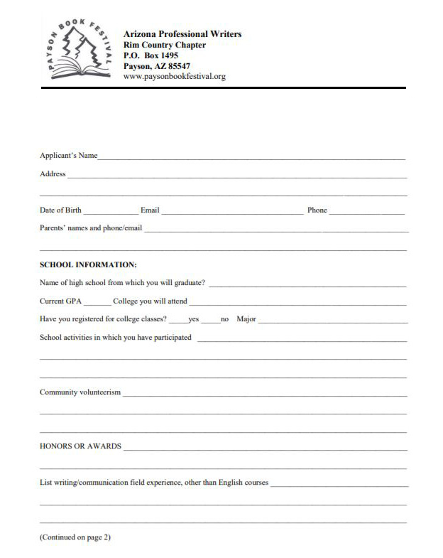

Journalism/Communication Scholarship Application Form for Graduating High School Seniors

Deadline - May 1, 2019

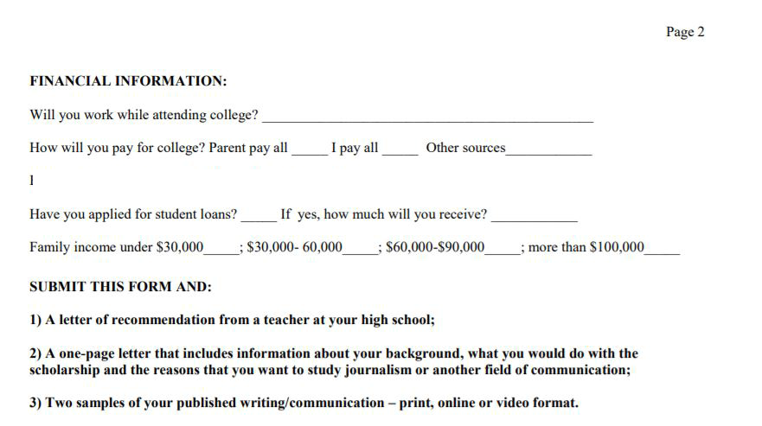

Parents pay all _____ I pay all _____ Share cost with parents_____ Other _____

Estimate the cost of one year at the college of your choice including: tuition, books, food/housing: $__________

$

Tell us where and when these samples were published.

Deadline for receiving your materials is May 1, 2019.

Send to:

Arizona Professional Writers Scholarship Application

PO Box 1495

Payson, AZ 85547

or via email to: connie.cockrell@gmail.com

For questions, please call 928-478-6793

